

|  |  |  |
| --- | --- | --- |
| **Week 1** | **Picture Pass Review**  **Muscle** | **Week 2** |
| **Say With Me Ages 2-3** | **Say With Me Ages 2-3** |
| This is a muscle!  I’m strong for God! | **A Baby and a Bush**  Birth of Moses and the burning bush | This is a muscle!  I’m strong for God! |
| **Questions Ages 4-K** | **What To Do**   1. **Take out** one Picture Pass from the Adventure Bag. 2. **Hold up** Picture Pass for all Small Groups to see. 3. **Ages 2-3:** Speak **Say With Me** statements out loud with the kids. 4. **Ages 4-K:** Ask review **Questions**   for the current week.   1. **Repeat** with remaining   Picture Passes. | **Questions Ages 4-K** |
| What’s this Picture Pass? *A muscle*  Do you have to be a grown-up to be strong for God? *No* | What’s this Picture Pass? *A muscle*  Who did Miriam and Moses grow strong for? *God* |
| **Week 3** | **Week 4** |
| **Say With Me Ages 2-3** |  | **Say With Me Ages 2-3** |
| This is a muscle!  I’m strong for God! |  | This is a muscle!  I’m strong for God! |
| **Questions Ages 4-K** |  | **Questions Ages 4-K** |
| What’s this Picture Pass? *A muscle*  What does this muscle help us remember? *We can grow strong for God.* |  | What’s this Picture Pass? *A muscle*  What can you do when you grow strong for God? *Big stuff for God* |

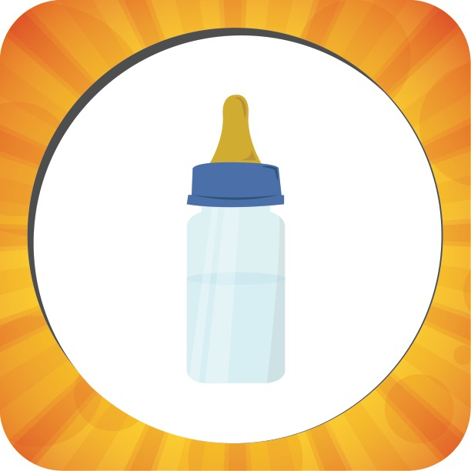

|  |  |  |
| --- | --- | --- |
| **Week 1** | **Picture Pass Review**  **Bottle** | **Week 2** |
| **Say With Me Ages 2-3** | **Say With Me Ages 2-3** |
| This is a bottle!  I’m not a baby! | **A Baby and a Bush**  Birth of Moses and the burning bush | This is a bottle!  I’m not a baby! |
| **Questions Ages 4-K** | **What To Do**   1. **Take out** one Picture Pass from the Adventure Bag. 2. **Hold up** Picture Pass for all Small Groups to see. 3. **Ages 2-3:** Speak **Say With Me** statements out loud with the kids. 4. **Ages 4-K:** Ask review **Questions**   for the current week.   1. **Repeat** with remaining   Picture Passes. | **Questions Ages 4-K** |
| What’s this Picture Pass? *A bottle*  Is a baby strong enough to do big stuff for God? *No* | What’s this Picture Pass? *A bottle*  If you’re acting like a baby, are you acting strong for God? *No* |
| **Week 3** | **Week 4** |
| **Say With Me Ages 2-3** |  | **Say With Me Ages 2-3** |
| This is a bottle!  I’m not a baby! |  | This is a bottle!  I’m not a baby! |
| **Questions Ages 4-K** |  | **Questions Ages 4-K** |
| What’s this Picture Pass? *A bottle*  What does this bottle help us remember? *We’re not babies!* |  | What’s this Picture Pass? *A bottle*  If you’re acting like a baby, what kind of stuff will you do? *Answers will vary, but examples are throwing fits, being selfish, not taking care of yourself, etc.* |

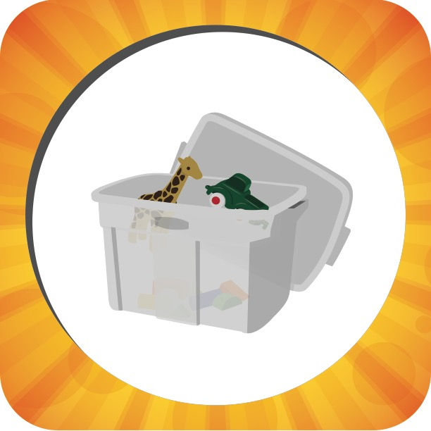

|  |  |  |
| --- | --- | --- |
| **Week 1** | **Picture Pass Review**  **Clean Up** | **Week 2** |
| **Say With Me Ages 2-3** | **Say With Me Ages 2-3** |
| This shows clean up!  Obey little stuff! | **A Baby and a Bush**  Birth of Moses and the burning bush | This shows clean up!  Obey little stuff! |
| **Questions Ages 4-K** | **What To Do**   1. **Take out** one Picture Pass from the Adventure Bag. 2. **Hold up** Picture Pass for all Small Groups to see. 3. **Ages 2-3:** Speak **Say With Me** statements out loud with the kids. 4. **Ages 4-K:** Ask review **Questions**   for the current week.   1. **Repeat** with remaining   Picture Passes. | **Questions Ages 4-K** |
| What’s this Picture Pass show? *Clean up*  What little job did Blinky and Shine do to show they’re strong for God? *They cleaned up.* | What’s this Picture Pass show? *Clean up*  If you clean up every day all by yourself, are you ready to do bigger stuff? *Yes* |
| **Week 3** | **Week 4** |
| **Say With Me Ages 2-3** |  | **Say With Me Ages 2-3** |
| This shows clean up!  Obey little stuff! |  | This shows clean up!  Obey little stuff! |
| **Questions Ages 4-K** |  | **Questions Ages 4-K** |
| What’s this Picture Pass show? *Clean up*  Should you wait until someone asks you to clean up? *No* |  | What’s this Picture Pass show? *Clean up*  Cleaning up is good! What’s some more big stuff you can do? *Answers will vary, but examples are take care of a baby, run the vacuum, help others, tell my friends about Jesus, etc.* |