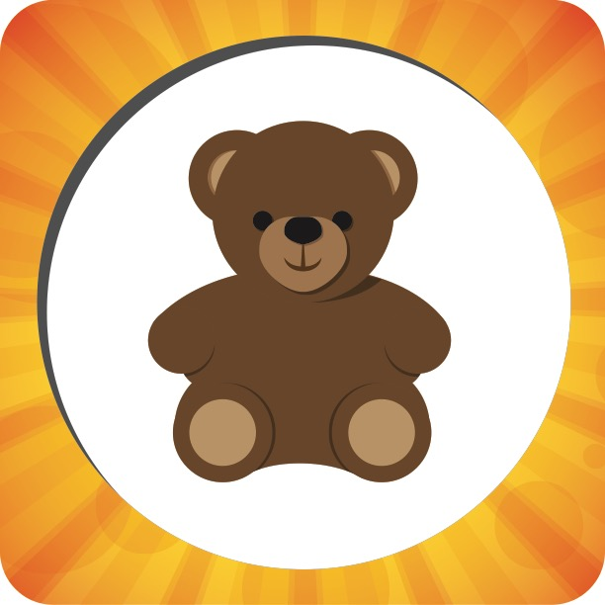

|  |  |  |
| --- | --- | --- |
| **Week 1** | **Picture Pass Review**  **Bear** | **Week 2** |
| **Say With Me Ages 2-3** | **Say With Me Ages 2-3** |
| This is a bear!  I can share! | **Through the Roof**  Jesus heals a paralyzed man | This is a bear!  I can share! |
| **Questions Ages 4-K** | **What To Do**   1. **Take out** one Picture Pass from the Adventure Bag. 2. **Hold up** Picture Pass for all Small Groups to see. 3. **Ages 2-3:** Speak **Say With Me** statements out loud with the kids. 4. **Ages 4-K:** Ask review **Questions**   for the current week.   1. **Repeat** with remaining   Picture Passes. | **Questions Ages 4-K** |
| What’s this Picture Pass? *A bear*  When you don’t feel like sharing, who can help you? *God* | What’s this Picture Pass? *A bear*  This bear is Emily’s favorite toy. What can she do with it to be a good friend? *Share it with others* |
| **Week 3** | **Week 4** |
| **Say With Me Ages 2-3** |  | **Say With Me Ages 2-3** |
| This is a bear!  I can share! |  | This is a bear!  I can share! |
| **Questions Ages 4-K** |  | **Questions Ages 4-K** |
| What’s this Picture Pass? *A bear*  Who can you share your toys with? *Friends, family, people who are in need* |  | What’s this Picture Pass? *A bear*  Why is sharing important?  *Sharing shows I care, and sharing shows God’s love.* |



|  |  |  |
| --- | --- | --- |
| **Week 1** | **Picture Pass Review**  **Drink** | **Week 2** |
| **Say With Me Ages 2-3** | **Say With Me Ages 2-3** |
| This is a drink!  Give to God’s people! | **Through the Roof**  Jesus heals a paralyzed man | This is a drink!  Give to God’s people! |
| **Questions Ages 4-K** | **What To Do**   1. **Take out** one Picture Pass from the Adventure Bag. 2. **Hold up** Picture Pass for all Small Groups to see. 3. **Ages 2-3:** Speak **Say With Me** statements out loud with the kids. 4. **Ages 4-K:** Ask review **Questions**   for the current week.   1. **Repeat** with remaining   Picture Passes. | **Questions Ages 4-K** |
| What’s this Picture Pass? *A drink*  What does this drink remind us to do? *Give people what they need.* | What’s this Picture Pass? *A drink*  Why do you give to people who are in need? *To be a good friend,*  *to show God’s love* |
| **Week 3** | **Week 4** |
| **Say With Me Ages 2-3** |  | **Say With Me Ages 2-3** |
| This is a drink!  Give to God’s people! |  | This is a drink!  Give to God’s people! |
| **Questions Ages 4-K** |  | **Questions Ages 4-K** |
| What’s this Picture Pass? *A drink*  How do you find out if someone needs something? *Listen to them, look at them, and pay attention to them.* |  | What’s this Picture Pass? *A drink*  When is it safe to give strangers what they need? *When I’m with a teacher, leader, or a grown up in my family* |



|  |  |  |
| --- | --- | --- |
| **Week 1** | **Picture Pass Review**  **Hand** | **Week 2** |
| **Say With Me Ages 2-3** | **Say With Me Ages 2-3** |
| This is a hand!  I help with my hands! | **Through the Roof**  Jesus heals a paralyzed man | This is a hand!  I help with my hands! |
| **Questions Ages 4-K** | **What To Do**   1. **Take out** one Picture Pass from the Adventure Bag. 2. **Hold up** Picture Pass for all Small Groups to see. 3. **Ages 2-3:** Speak **Say With Me** statements out loud with the kids. 4. **Ages 4-K:** Ask review **Questions**   for the current week.   1. **Repeat** with remaining   Picture Passes. | **Questions Ages 4-K** |
| What’s this Picture Pass? *A hand*  What does this hand remind us to do? *Help people who need help.* | What’s this Picture Pass? *A hand*  What can you do to help others? *Pick them up when they fall down, hug them when they’re sad, etc.* |
| **Week 3** | **Week 4** |
| **Say With Me Ages 2-3** |  | **Say With Me Ages 2-3** |
| This is a hand!  I help with my hands! |  | This is a hand!  I help with my hands! |
| **Questions Ages 4-K** |  | **Questions Ages 4-K** |
| What’s this Picture Pass? *A hand*  Should you help people if it’s not fun? *Yes* |  | What’s this Picture Pass? *A hand*  Why should you help people? *To be a good friend, to show God’s love* |