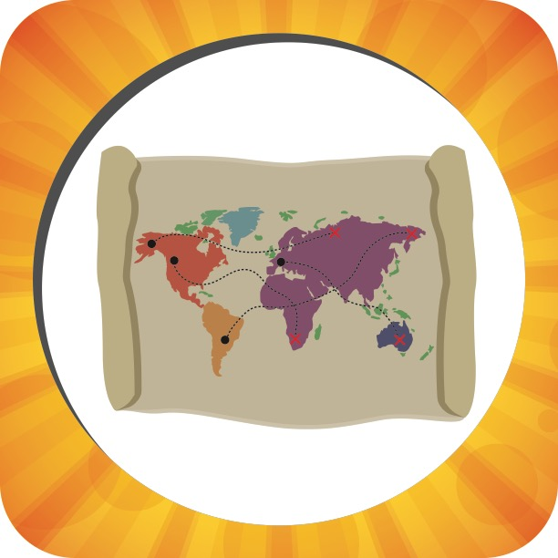

|  |  |  |
| --- | --- | --- |
| **Week 1** | **Picture Pass Review**  **Map** | **Week 2** |
| **Say With Me Ages 2-3** | **Say With Me Ages 2-3** |
| This is a map!  Share Jesus with the world! | **Journeys for Jesus**  Paul’s journey and trials | This is a map!  Share Jesus with the world! |
| **Questions Ages 4-K** | **What To Do**   1. **Take out** one Picture Pass from the Adventure Bag. 2. **Hold up** Picture Pass for all Small Groups to see. 3. **Ages 2-3:** Speak **Say With Me** statements out loud with the kids. 4. **Ages 4-K:** Ask review **Questions**   for the current week.   1. **Repeat** with remaining   Picture Passes. | **Questions Ages 4-K** |
| What’s this Picture Pass? *A map*  What do you see on this map? *The whole world* | What’s this Picture Pass? *A map*  Who can you share with the whole world? *Jesus* |
| **Week 3** | **Week 4** |
| **Say With Me Ages 2-3** |  | **Say With Me Ages 2-3** |
| This is a map!  Share Jesus with the world! |  | This is a map!  Share Jesus with the world! |
| **Questions Ages 4-K** |  | **Questions Ages 4-K** |
| What’s this Picture Pass? *A map*  Who tells us to share God’s Good News with the whole world? *Jesus; God* |  | What’s this Picture Pass? *A map*  Who needs us to share God’s Good News with them? *Everyone in the whole world* |



|  |  |  |
| --- | --- | --- |
| **Week 1** | **Picture Pass Review**  **Park** | **Week 2** |
| **Say With Me Ages 2-3** | **Say With Me Ages 2-3** |
| This is a park!  Share Jesus everywhere! | **Journeys for Jesus**  Paul’s journey and trials | This is a park!  Share Jesus everywhere! |
| **Questions Ages 4-K** | **What To Do**   1. **Take out** one Picture Pass from the Adventure Bag. 2. **Hold up** Picture Pass for all Small Groups to see. 3. **Ages 2-3:** Speak **Say With Me** statements out loud with the kids. 4. **Ages 4-K:** Ask review **Questions**   for the current week.   1. **Repeat** with remaining   Picture Passes. | **Questions Ages 4-K** |
| What’s this Picture Pass? *A park*  Can you share God’s Good News about Jesus at the park? *Yes* | What’s this Picture Pass? *A park*  Do you have to travel far away to share God’s Good News about Jesus? *No* |
| **Week 3** | **Week 4** |
| **Say With Me Ages 2-3** |  | **Say With Me Ages 2-3** |
| This is a park!  Share Jesus everywhere! |  | This is a park!  Share Jesus everywhere! |
| **Questions Ages 4-K** |  | **Questions Ages 4-K** |
| What’s this Picture Pass? *A park*  What does Jesus tell us to share everywhere we go? *God’s Good News about Jesus* |  | What’s this Picture Pass? *A park*  You can share God’s Good News about Jesus at the park. Where else can you share about Jesus? *Answers will vary.* |



|  |  |  |
| --- | --- | --- |
| **Week 1** | **Picture Pass Review**  **Green Light** | **Week 2** |
| **Say With Me Ages 2-3** | **Say With Me Ages 2-3** |
| This is a green light!  Go, go, go share Jesus! | **Journeys for Jesus**  Paul’s journey and trials | This is a green light!  Go, go, go share Jesus! |
| **Questions Ages 4-K** | **What To Do**   1. **Take out** one Picture Pass from the Adventure Bag. 2. **Hold up** Picture Pass for all Small Groups to see. 3. **Ages 2-3:** Speak **Say With Me** statements out loud with the kids. 4. **Ages 4-K:** Ask review **Questions**   for the current week.   1. **Repeat** with remaining   Picture Passes. | **Questions Ages 4-K** |
| What’s this Picture Pass? *A green light*  Who should you go, go, go share Jesus with? *Everyone* | What’s this Picture Pass? *A green light*  Who tells us to go, go, go tell the Good News? *Jesus; God* |
| **Week 3** | **Week 4** |
| **Say With Me Ages 2-3** |  | **Say With Me Ages 2-3** |
| This is a green light!  Go, go, go share Jesus! |  | This is a green light!  Go, go, go share Jesus! |
| **Questions Ages 4-K** |  | **Questions Ages 4-K** |
| What’s this Picture Pass? *A green light*  Can you share Jesus with everyone, everywhere you go, go, go? *Yes* |  | What’s this Picture Pass? *A green light*  Do you ever need to stop sharing God’s Good News with everyone? *No* |