

|  |  |  |
| --- | --- | --- |
| **Week 1** | **Picture Pass Review**  **Moon** | **Week 2** |
| **Say With Me Ages 2-3** | **Say With Me Ages 2-3** |
| This is the moon!  God helps me! | **A Roaring Rescue**  Daniel and the lions’ den | This is the moon!  God helps me! |
| **Questions Ages 4-K** | **What To Do**   1. **Take out** one Picture Pass from the Adventure Bag. 2. **Hold up** Picture Pass for all Small Groups to see. 3. **Ages 2-3:** Speak **Say With Me** statements out loud with the kids. 4. **Ages 4-K:** Ask review **Questions**   for the current week.   1. **Repeat** with remaining   Picture Passes. | **Questions Ages 4-K** |
| What’s this Picture Pass? *The moon*  How can you ask God for help when you’re afraid? *Pray* | What’s this Picture Pass? *The moon*  Who helps you say goodbye to fear? *God* |
| **Week 3** | **Week 4** |
| **Say With Me Ages 2-3** |  | **Say With Me Ages 2-3** |
| This is the moon!  God helps me! |  | This is the moon!  God helps me! |
| **Questions Ages 4-K** |  | **Questions Ages 4-K** |
| What’s this Picture Pass? *The moon*  When it’s dark at night, do you need to be afraid? *No* |  | What’s this Picture Pass? *The moon*  What can God help you say to fear? *Goodbye, fear! God is here!* |



|  |  |  |
| --- | --- | --- |
| **Week 1** | **Picture Pass Review**  **Shield** | **Week 2** |
| **Say With Me Ages 2-3** | **Say With Me Ages 2-3** |
| This shows a shield!  God fights fear! | **A Roaring Rescue**  Daniel and the lions’ den | This shows a shield!  God fights fear! |
| **Questions Ages 4-K** | **What To Do**   1. **Take out** one Picture Pass from the Adventure Bag. 2. **Hold up** Picture Pass for all Small Groups to see. 3. **Ages 2-3:** Speak **Say With Me** statements out loud with the kids. 4. **Ages 4-K:** Ask review **Questions**   for the current week.   1. **Repeat** with remaining   Picture Passes. | **Questions Ages 4-K** |
| What’s this Picture Pass? *A shield*  When you’re afraid, what will God help you fight? *Fear.* | What’s this Picture Pass? *A shield*  What kind of person holds a shield? *Warrior, police officer, military, etc.* |
| **Week 3** | **Week 4** |
| **Say With Me Ages 2-3** |  | **Say With Me Ages 2-3** |
| This shows a shield!  God fights fear! |  | This shows a shield!  God fights fear! |
| **Questions Ages 4-K** |  | **Questions Ages 4-K** |
| What’s this Picture Pass? *A shield*  Who helps you fight fear? *God* |  | What’s this Picture Pass? *A shield*  How do you fight fear? *Pray; trust God to help you* |

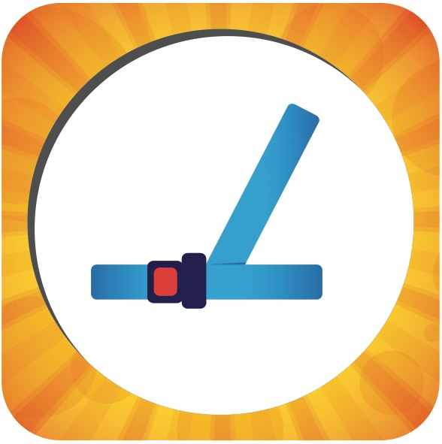

|  |  |  |
| --- | --- | --- |
| **Week 1** | **Picture Pass Review**  **Seat belt** | **Week 2** |
| **Say With Me Ages 2-3** | **Say With Me Ages 2-3** |
| This is a seat belt!  God takes care of me! | **A Roaring Rescue**  Daniel and the lions’ den | This is a seat belt!  God takes care of me! |
| **Questions Ages 4-K** | **What To Do**   1. **Take out** one Picture Pass from the Adventure Bag. 2. **Hold up** Picture Pass for all Small Groups to see. 3. **Ages 2-3:** Speak **Say With Me** statements out loud with the kids. 4. **Ages 4-K:** Ask review **Questions**   for the current week.   1. **Repeat** with remaining   Picture Passes. | **Questions Ages 4-K** |
| What’s this Picture Pass? *A seat belt*  Who keeps you safe? *God* | What’s this Picture Pass? *A seat belt*  When you follow Jesus, do you need to be afraid? *No* |
| **Week 3** | **Week 4** |
| **Say With Me Ages 2-3** |  | **Say With Me Ages 2-3** |
| This is a seat belt!  God takes care of me! |  | This is a seat belt!  God takes care of me! |
| **Questions Ages 4-K** |  | **Questions Ages 4-K** |
| What’s this Picture Pass? *A seat belt*  Is God taking care of you when you trust and follow Jesus? *Yes* |  | What’s this Picture Pass? *A seat belt*  Who is always taking care of you? *God* |